Ann Marie De Gregoria
Cell: 516-770-7131
Fax: 631-295-1305
annmarie@b4ln.com
Health History Form:

Name: ____________________________________ Date of Birth: ______________________

Address:_______________________________________________________________________
City State Zip
Phone: ___________________ Email:_____________________ Height_____ Weight _____

Primary Physician/Health Care Providers (including massage/acupuncture, etc)
________________________________________________________________________________
phone/email
________________________________________________________________________________
phone/email

Emergency Contact: ___________________________________________________________
Name relationship phone#
How did you hear about us? _____________________________________________________

Section I
Primary Reasons For Visit:
1. ______________________________________________________________________________

2. ______________________________________________________________________________

Do You Have a History of any Illness, Surgery, or Hospitalization?
1. ______________________________________________________________________________

2. ______________________________________________________________________________

Have you experienced any of the following? Please check all that apply.
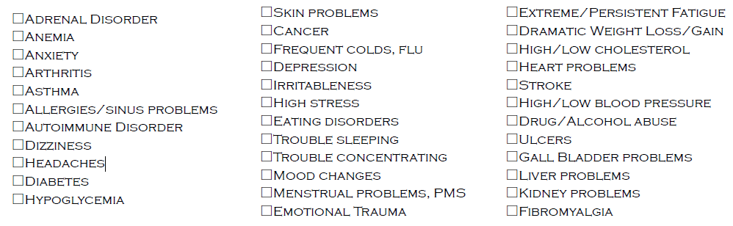
Please provide additional detail on checked items: _______________________________________________________________________________________________________________________________________________________________________________________________________________________________________________________________

Any family history of disease or illness? _______________________________________________________________________________________________________________________________________________________________________________________________________________________________________________________________

Date of last course of antibiotics ____________ Reason_________________________________

Blood Type ___________

Date of last lab work/blood draw ___________ (please bring copies if within past six months)

Section II
Do you exercise? If so what kind and how often? ____________________________________
____________________________________________________________________________________

What is your normal weekday sleep schedule? Go to bed__________ Rise: ____________

Any trouble falling/staying asleep?: _________________________________________________

Have you experienced long periods of stress? _______________________________________

What is your stress level now (1-10)? _________________________________________________

Any constipation, diarrhea, gas, heartburn or bloating? ______________________________

How would you rate your job satisfaction (1-10)? _____________________________________

How do you spend your free-time? __________________________________________________
____________________________________________________________________________________

Section III (PLEASE BRING ANY WRAPPERS OF FOODS YOU COMMONLY CONSUME)

Typical Breakfasts____________________________________________________________________
_____________________________________________________________________________________

Typical Lunches_____________________________________________________________________
_____________________________________________________________________________________

Typical Dinners ______________________________________________________________________
_____________________________________________________________________________________

Typical Snacks ______________________________________________________________________
_____________________________________________________________________________________

Top 3 Favorite Foods Drink: Top 3 Least Favorite Foods/Drink:
1. 1.
2. 2.
3. 3.

How much water do you drink on average? __________________________________________

Morning beverage/what goes into it? ________________________________________________

How many alcoholic beverages do you consume (daily/monthly)? ____________________

How often do you miss/skip meals? __________________________________________________

Do you ever feel tired or crave sweets after a meal? __________________________________
What foods do you crave the most? _________________________________________________

How many meals do you eat out per week ______ Where? ____________________________
_____________________________________________________________________________________

Where do you eat? (i.e. table, watching tv, desk) _____________________________________

Do you like to cook? What?__________________________________________________________

Where do you grocery shop?________________________________________________________

Are you on a strict food budget? Y/N $___________ spending per week/month

Any dietary restrictions/allergies?___________________________________________________

Your relationship with food? (i.e. Good, confusing, frustrating)________________________

Please list all medications/vitamins/supplements you currently take and why:
Name Dosage Reason Duration
____________________________________________________________________________________
____________________________________________________________________________________
____________________________________________________________________________________
____________________________________________________________________________________
____________________________________________________________________________________

* PLEASE BRING THESE BOTTLES WITH YOU TO THE APPOINTMENT
What brands of body care products do you use? (shampoo, lotion, deodorant, etc.)
____________________________________________________________________________________
____________________________________________________________________________________
What brands of cleaning supplies do you use? Do you clean often? ___________________
_____________________________________________________________________________________

Section IV - Health Objectives

Please list three goals you’d like to accomplish by working on your diet and health,
and when you’d like to achieve them by:

1. ___________________________________________________________________________
Goal Timeframe

2. ___________________________________________________________________________
Goal Timeframe

3. ___________________________________________________________________________
Goal Timeframe

What has kept you from reaching these goals in the past? _____________________
_____________________________________________________________________________

On a scale of 1-10, how motivated are you to achieve these goals by making diet
changes: (10 being let’s start RIGHT now, 5 being I am excited to reach these goals,
but I am not very motivated right now, 1 being I really don’t want to make any changes
to my diet or lifestyle). _________

What motivates you the most? _________________________________________

What are you not willing to change?____________________________________

What are your biggest temptations that could keep you from reaching your goals?

_______________________________________________________________________________

What/who supports your goals? How?

_______________________________________________________________________________

What/who does not support your goals? How?

_______________________________________________________________________________

What does success look/feel like to you?

_______________________________________________________________________________

Payment and Cancellation Policy
Payment is due at time of first (1st) session. Payment is non-refundable. If cancelling an appointment, 24 hour advanced notice is required and the amount of the session will be applied to a future appointment, made within 1 week period of time. No-shows, or cancellations, without 24 hour notice, will be charged in full for the session. We will hold your appointment for 15 minutes and you will be allotted the balance of time. After 15 minutes, it will be considered a no-show appointment.
Informed Consent For Nutrition Therapy

The intent of this document is to inform, educate and improve communication between both parties. It is intended to clarify what Ann Marie does, and does not do.

I understand that Ann Marie is a nutritionist therapist from Nutrition Therapy Institute, and that she has 260+ hours of training, but is not a “licensed” or “certified” nutritionist. I understand that Ann Marie is providing nutritional counseling services that may include: a nutritional evaluation, program of diet, nutritional supplements and lifestyle changes for the purpose of reducing stress and enhancing my health. Additionally, it may include instruction in the development of eating habits, physical exercises, rest, healthy home and workplace environments, as well as attitudinal and behavior changes.

The counseling offered under this agreement is acknowledged and understood to be of a strictly non-medical and non-psychological nature; and is accepted solely and exclusively for instructional purposes only. I understand that natural health care is not intended as a diagnosis, treatment, prescription or cure for any disease, (mental or physical), and is not intended as a substitute for regular medical care or medical examination. It is recommended that I attend my personal physician for specific ailments. Once diagnosis is conducted and established by a medical doctor, the Nutrition Therapist can offer alternative approaches for correction through nutritional guidance and address areas of concern, however there are no guarantees.

I acknowledge and understand that Ann Marie must be made fully aware of any existing medical conditions. I have completed my medical history form, as provided by my therapist, and have disclosed any and all medical conditions affecting me. It is my responsibility to keep the therapist updated on my medical history/changes.

I agree to accept and pay for certain nutritional consultation services offered to me by Ann Marie DeGregoria, and have read the above information. I give consent to nutrition therapy. I also authorize my therapist to release any information pertaining to my conditions/treatments to other caregivers.

The information I have provided is true and complete to the best of my knowledge. This agreement is being signed voluntarily and not under duress of any kind.

Signature: ___________________________________ Date:_______________
Name: ___________________________________________________________
*Disclaimer: These recommendations are not intended to augment treatment or prescriptions for any disease, or as a substitute for regular medical care. It is not intended to diagnose, prognosticate, or treat disease.

